**BCDE102 Assessment 3 Daniel Wild**

**Iteration 3**

**WHERE:**

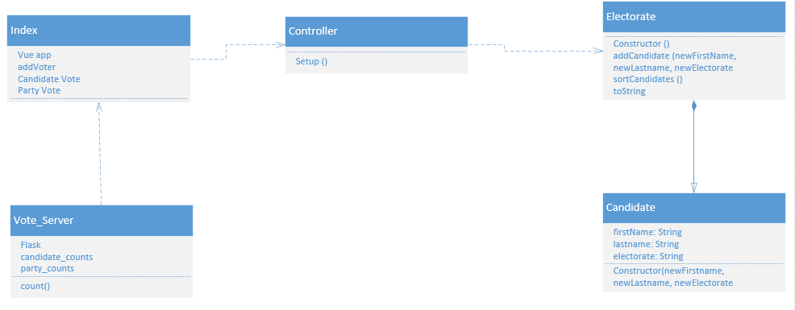

**WHAT:**

The goal of iteration 3 is to take version 2 and add in a python server that will use flask to take the info from the radio buttons in the Index and store them in count functions in python. So that a total vote count can be viewed in python or in the browser.

The Tasks:

1. Fix issues caused by the last iteration
2. Add in anything I ran out of time to add in iteration 2
3. Create a server in python using flask that will link with Index html and take in the names of the candidate and party voted for
4. Add in code that lets me view the total number of votes from the browser
5. Write unit tests to make sue the python works correctly

Task Time Estimates

* Fix issues 30 minutes
* Update version 2 features 30 minutes
* Python server 2 hours
* Votes in browser 10 minutes
* Unit tests 1 hour

Estimated Total Time: 4 hours 10 minutes

Planned product

Task Times

* Fix issues 10 minutes
* Update features 30 minutes
* Python Server 1 hour
* Votes in browser 15 minutes
* Unit tests 30 minutes

Total Time: 2 hour 25 minutes

**How:**

Unit tests

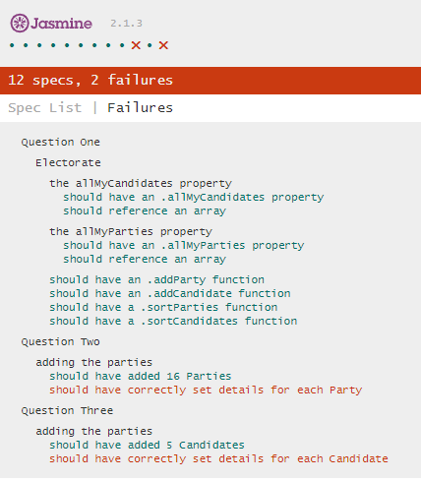JS

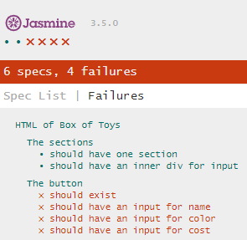HTML

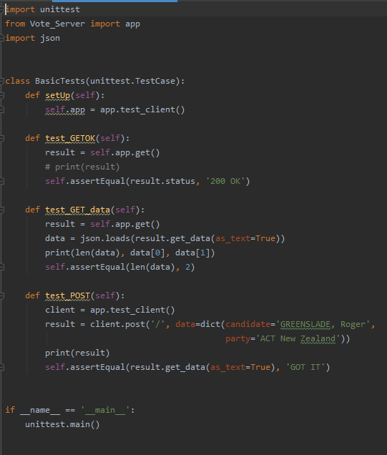Python

User Stories

I am a voter from Wairarapa I want to be able to see the candidates and parties I can vote for. I want to be able to vote for only one of each party and candidate.

I am a new New Zealand voter I want to be able to see the explanation for each vote I am able to make and have a clear form that is easy to read.

I am a vote counter with admin rights I want to be able to see the total number of votes that have been submitted for each candidate and each party.

I am a candidate I want to know what the total number of votes there were and find out who won.

Burndown Chart

Activity diagram

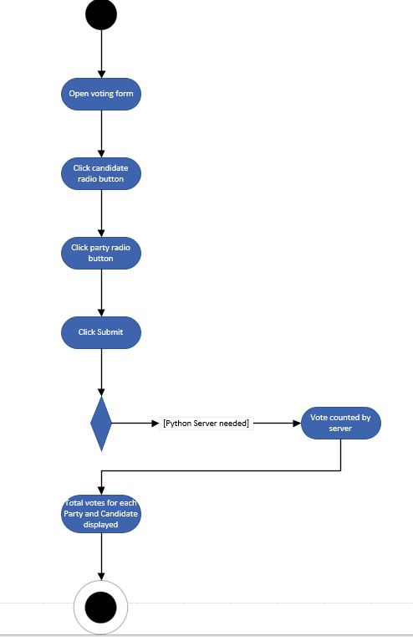

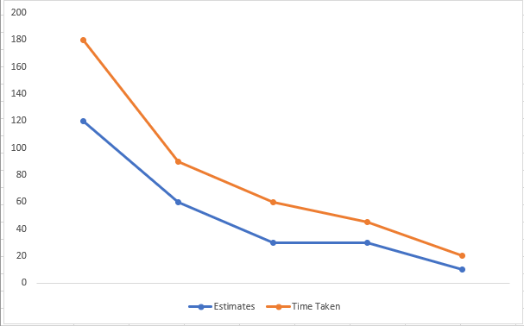

**Evaluation:**

Style

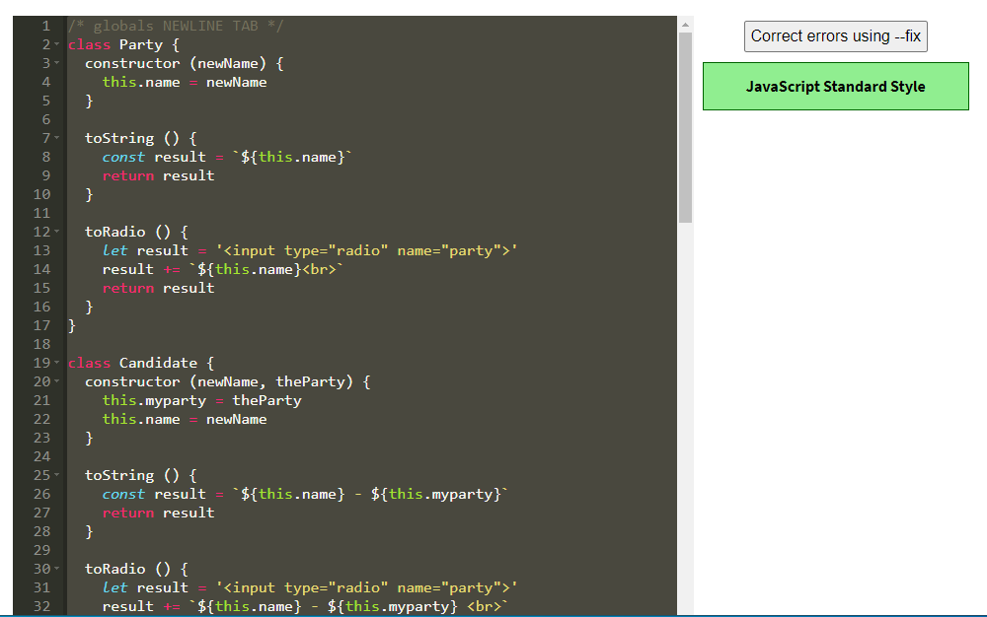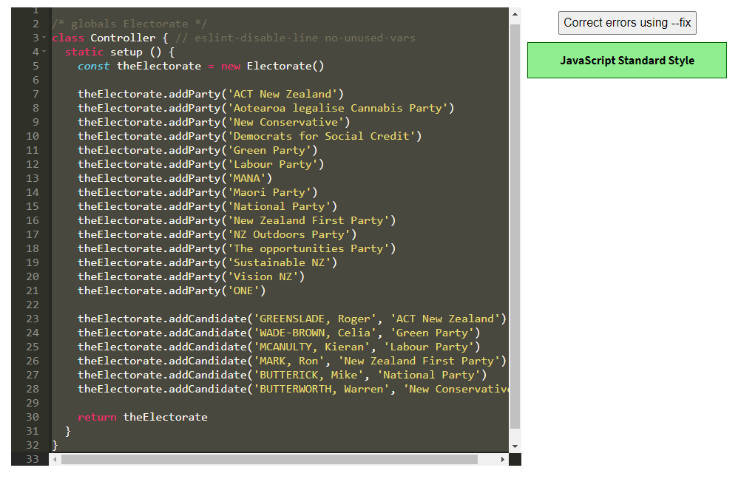 JS

HTML

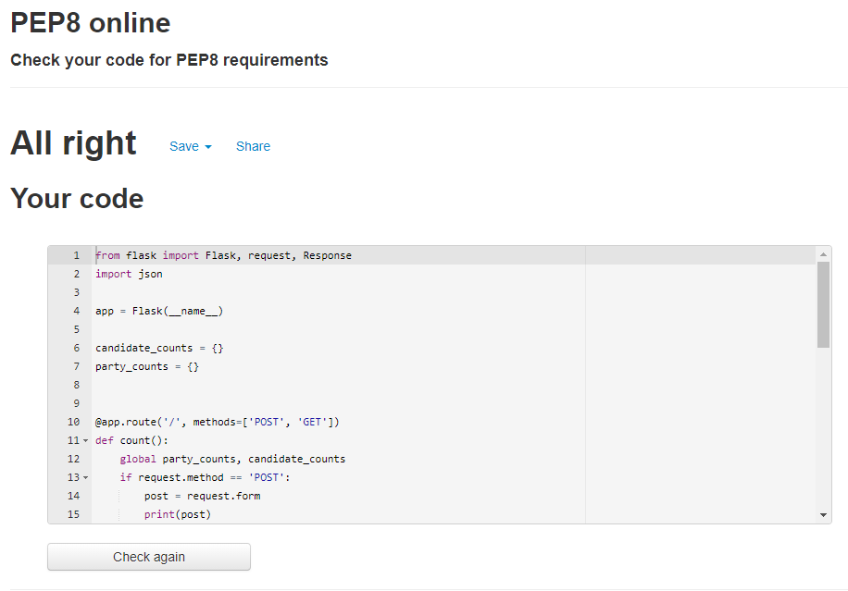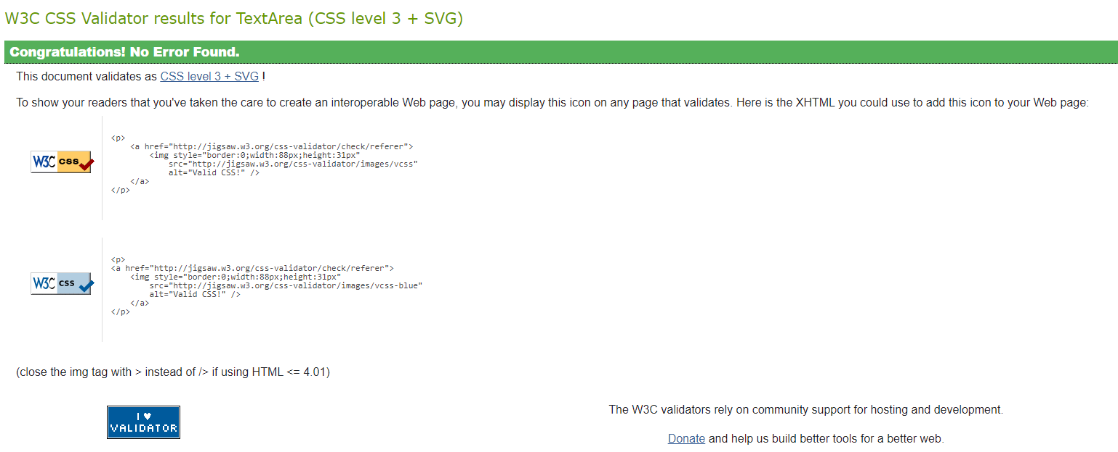Python

**What happened vs what was planned:**

The goal of iteration 3 was to create a python server that connected to the html voting form and could pass the text from each selected radio button through when the submit button was clicked so that votes could be counted. This work well and I was able to get it to both show in the terminal in python and in a separate html form.

**Performance Review:**

Everything went well in this iteration. I was able to get the server to connect to the html form and it is able to submit vote data back to the server to keep a count of. I was also able to write unit tests in python that make sure the server is working correctly and gets the type of vote info it expects.